# Operators in JS

* Arithmetic Operators
* Comparison Operators
* Logical Operators
* Assignment Operators
* Type Operators
* Bitwise Operators
* Ternary Operators

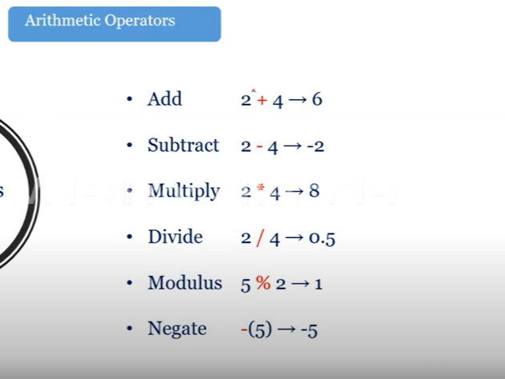

Uninary Operator

++ 🡪 a++

--a--

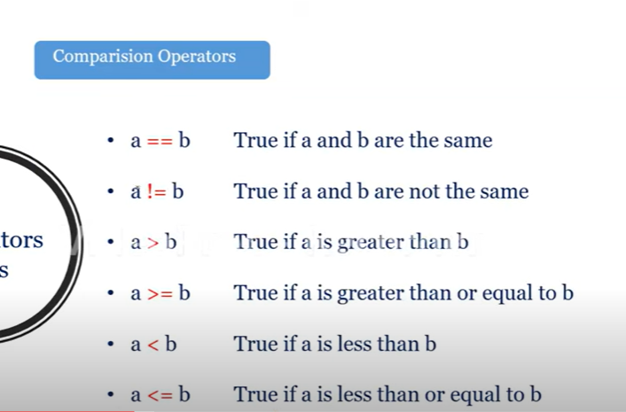

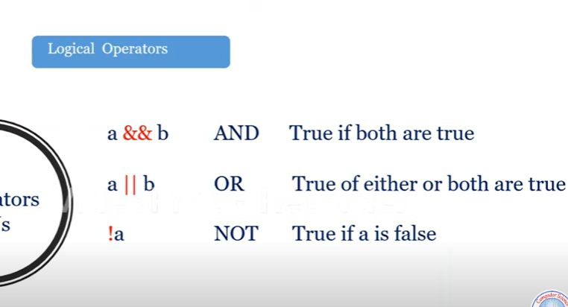

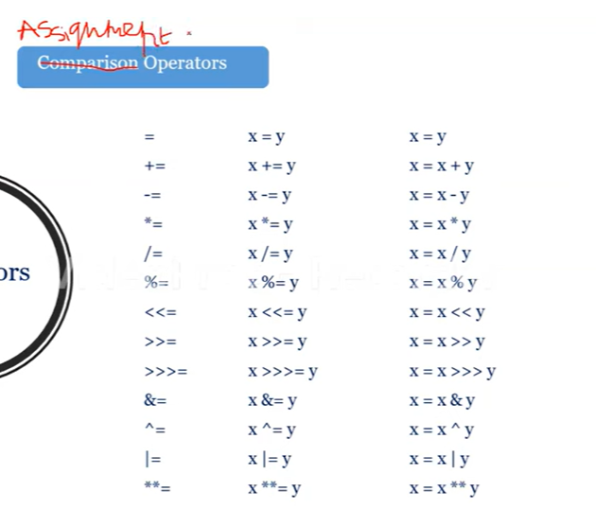

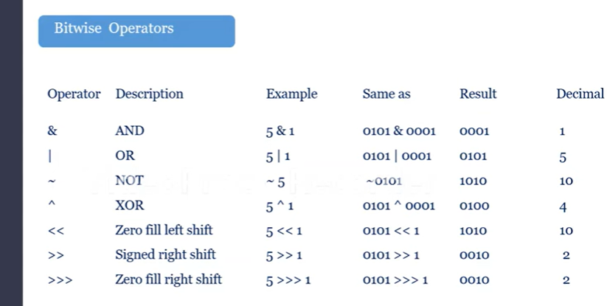

Tenary Operators:

a>b?a:b